|  |
| --- |
| YEAR 12 Essentials Mathematics  Semester 1 2017  Test 4 – **Bivariate Data and Bias**  **.** |
| Total Marks: 20 marks  Name: ______________________ Total Time: 30 minutes |



***Full working out must be shown to get full marks.***

***Attempt all questions***

**Total Time: 30 minutes**

***Resources allowed:***

***1 A4 page, (1 side) of hand written notes, ruler***

***Calculator***

**Question 1: (12 marks: 5, 2, 1, 2, 2)**

A Mathematics teacher proposed that it was possible to predict a student’s final exam mark using that student’s first semester exam mark.

1. Firstly she put the previous year’s marks onto a scatterplot. Use the data below to show what her scatterplot would have looked like.

|  |  |  |  |  |  |  |  |  |  |  |  |  |  |  |  |  |
| --- | --- | --- | --- | --- | --- | --- | --- | --- | --- | --- | --- | --- | --- | --- | --- | --- |
| Student | A | B | C | D | E | F | G | H | I | J | K | L | M | N | O | P |
| 1st Exam % | 48 | 65 | 87 | 60 | 53 | 74 | 82 | 85 | 67 | 95 | 43 | 59 | 60 | 77 | 82 | 45 |
| 2nd Exam  % | 50 | 67 | 80 | 59 | 70 | 69 | 80 | 89 | 73 | 95 | 60 | 62 | 58 | 75 | 84 | 55 |



1. Describe the relationship between the first and second exam results.
2. Complete this sentence: If a student’s first exam results are high, than ……………
3. Use a line of best fit to predict the score for a student who missed the second exam but scored 75% in the first exam.
4. Student J scored 95% in both his fiirst and second exams. Does this mean that he can expect to score 95% in his exams in the next year too? Justify your answer.

**Question 2: (2 marks)**

An internet provider emailed its customers to ask them if they supported a new government tax on broadband. They then sent this data to the government who replied that their survey was biased. Give two reasons to support the government’s claim of bias.

**Question 3: (2 marks)**

Is the following statement true or false? Give a reason to justify your answer.

Random sampling is a good way to reduce response bias.

**Question 4: [4 marks:1, 1, 2]**

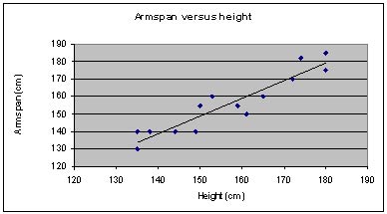

1. Use the scattergraph above to determine the approximate armspan of a person who is 150cm tall.
2. Now determine the approximate height of a person who has an armspan of 170cm.
3. What relationship do you see between a person’s height and their armspan?

**~END OF TEST~**